Supplementary Information Appendix for:
Rapid genomic DNA variation in newly hybridized carp lineages derived from Cyprinus carpio (♀) × Megalobrama amblycephala (♂)

Kaikun Luo^{1,2,*}, Shi Wang^{1,2,3,*}, Yeqing Fu^{1,2,*}, Pei Zhou^{1,2}, Xuexue Huang^{1,2}, Qianhong Gu^{1,2}, Wuhui Li^{1,2,4}, Yude Wang^{1,2,3}, Fangzhou Hu^{1,2,3}, Shaojun Liu^{1,2,†}

¹ State Key Laboratory of Developmental Biology of Freshwater Fish, Hunan Normal University, Changsha, 410081, Hunan, P.R. China
² College of Life Sciences, Hunan Normal University, Changsha, 410081, Hunan, P.R. China
³ College of Chemistry and Chemical Engineering, Hunan Normal University, Changsha, 410081, Hunan, P.R. China
⁴ Key Laboratory of Tropical and Subtropical Fisheries Resource Application and Cultivation, Ministry of Agriculture, Pearl River Fisheries Research Institute, Chinese Academy of Fishery Sciences, Guangzhou, 510380, Guangdong, P.R. China
†Corresponding author: Professor Shaojun Liu. Telephone number, 86-731-88873010, Fax number, 86-731-88873074, E-mail: lsj@hunnu.edu.cn
*These authors contributed equally to this work.

Author information:
Kaikun Luo, Email: 113264738@qq.com
Shi Wang, Email: wangshixyz@126.com
Yeqing Fu, Email: 1004013161@qq.com
Pei Zhou, Email: 848902780@qq.com
Xuexue Huang, Email: 1582729790@qq.com
Qianhong Gu, Email: qianhong_g@163.com
Wuhui Li, Email: 1058049690@qq.com
Yude Wang, Email: 461669793@qq.com
Fangzhou Hu, Email: hufangzhou90@163.com
Shaojun Liu, Email: lsj@hunnu.edu.cn

Figure Captions

Supplementary Figure S1. Variable sequence types (including haplotypes and recombinant clusters) in different Hox genes in these species. A: Variable sequence types (including haplotypes and recombinant clusters) in HoxA9a in these species. B: Variable sequence types (including haplotypes and recombinant clusters) in HoxA2b in these species. C: Variable sequence types (including haplotypes and recombinant clusters) in HoxA11b in these species. D: Variable sequence types (including haplotypes and recombinant clusters) in HoxB1a in these species.

Supplementary Figure S2. Variable sequence types (including haplotypes and recombinant clusters) in different Hox genes in these species. A: Variable sequence types in HoxB4a in these species. B: Variable sequence types in HoxB1b in these species. C: Variable sequence types (including haplotypes and recombinant clusters) in HoxC4a in these species. D: Variable sequence types in HoxC6b in these species.

Supplementary Figure S3. Variable sequence types (including haplotypes and recombinant clusters) in HoxB5b in these species.
Supplementary Information Figures

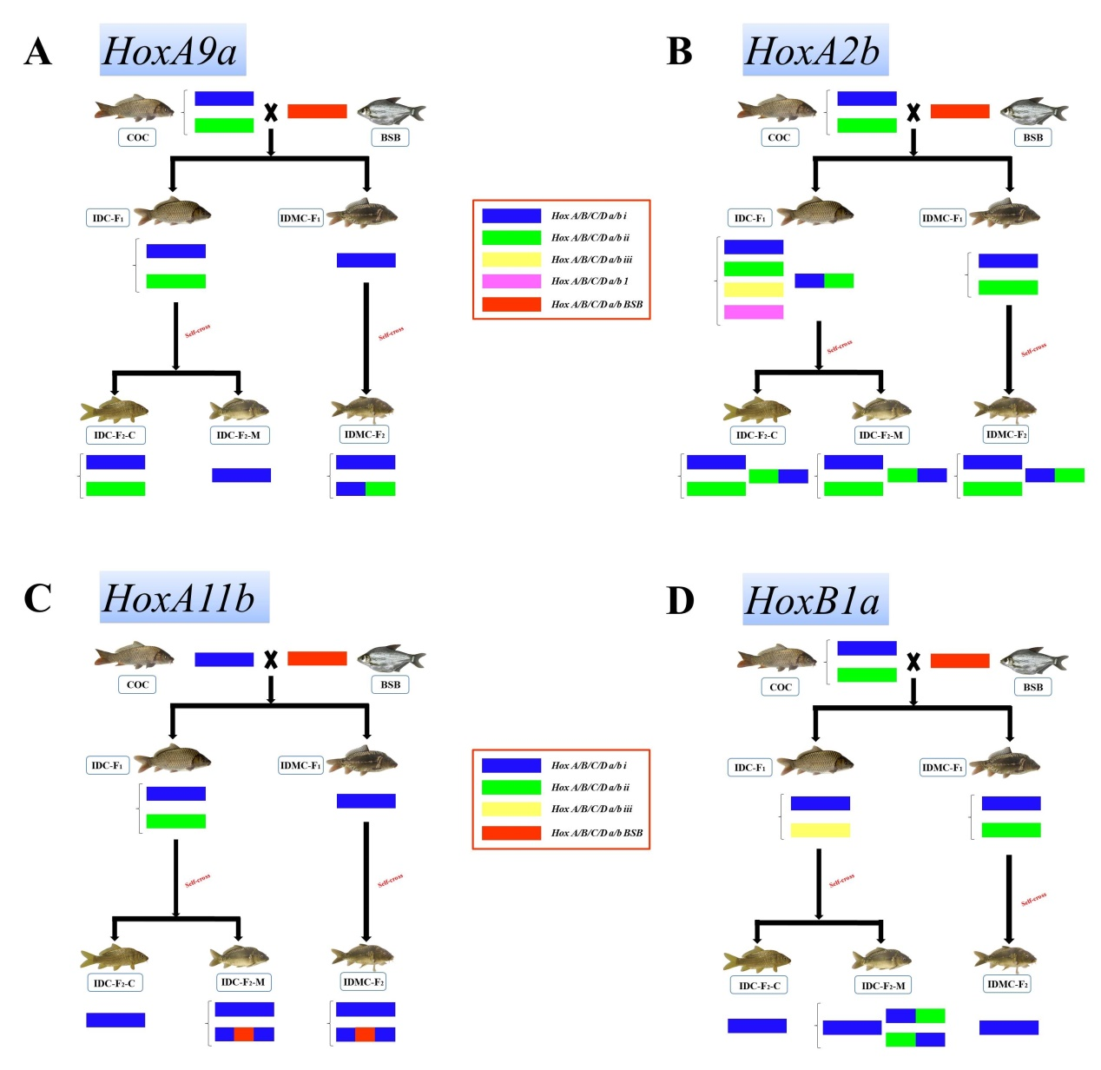

Supplementary Figure S1. Variable sequence types (including haplotypes and recombinant clusters) in different Hox genes in these species. A: Variable sequence types (including haplotypes and recombinant clusters) in HoxA9a in these species. B: Variable sequence types (including haplotypes and recombinant clusters) in HoxA2b in these species. C: Variable sequence types (including haplotypes and recombinant clusters) in HoxA11b in these species. D: Variable sequence types (including haplotypes and recombinant clusters) in HoxB1a in these species.

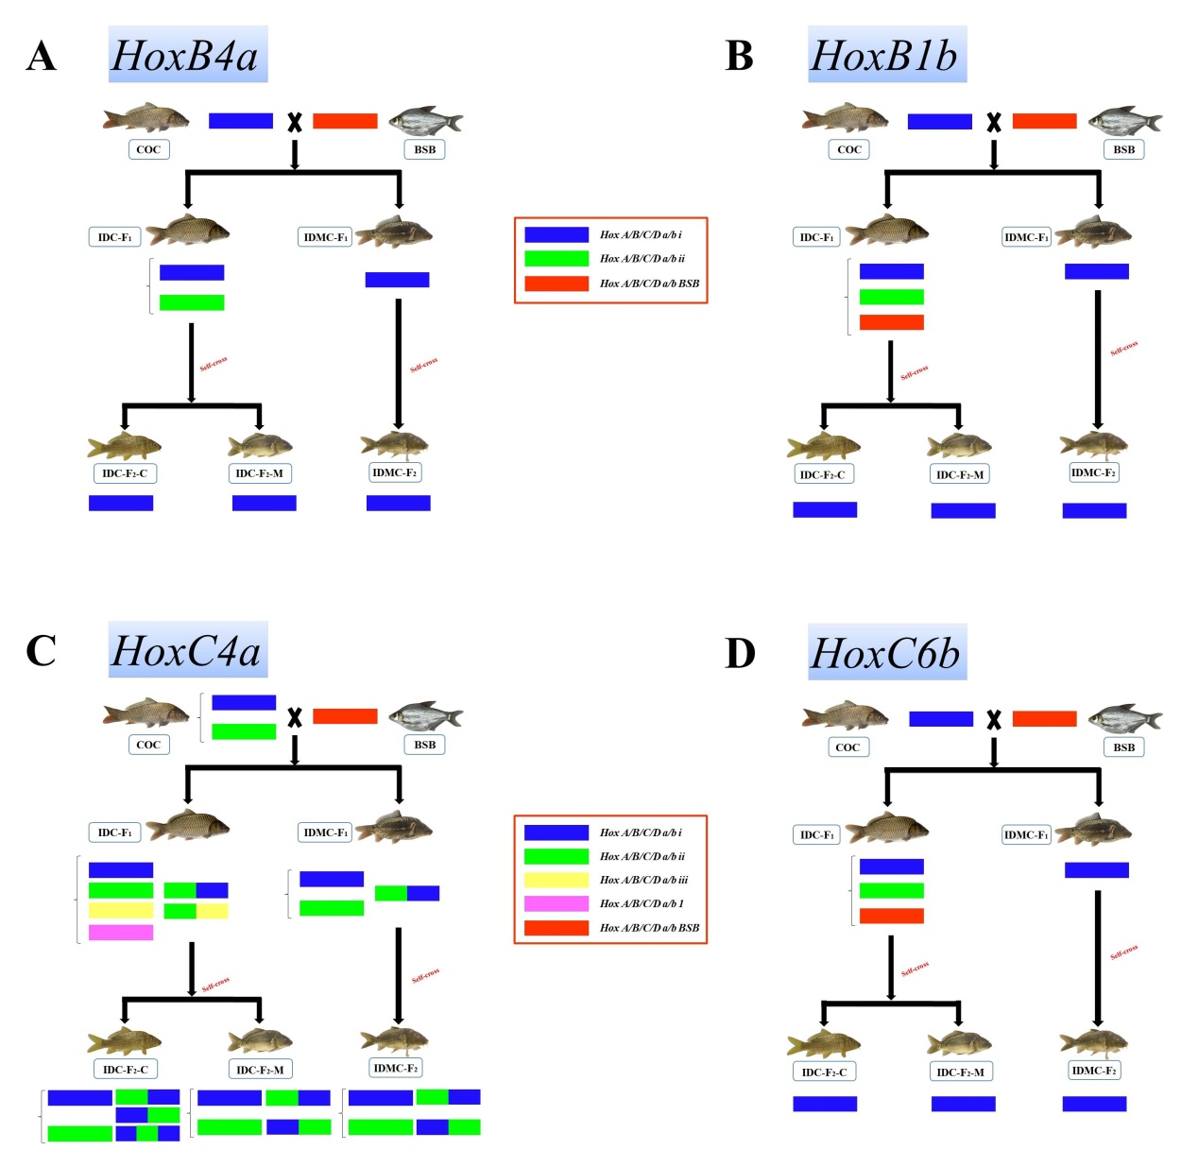

Supplementary Figure S2. Variable sequence types (including haplotypes and recombinant clusters) in different Hox genes in these species. A: Variable sequence types in HoxB4a in these species. B: Variable sequence types in HoxB1b in these species. C: Variable sequence types (including haplotypes and recombinant clusters) in HoxC4a in these species. D: Variable sequence types in HoxC6b in these species.

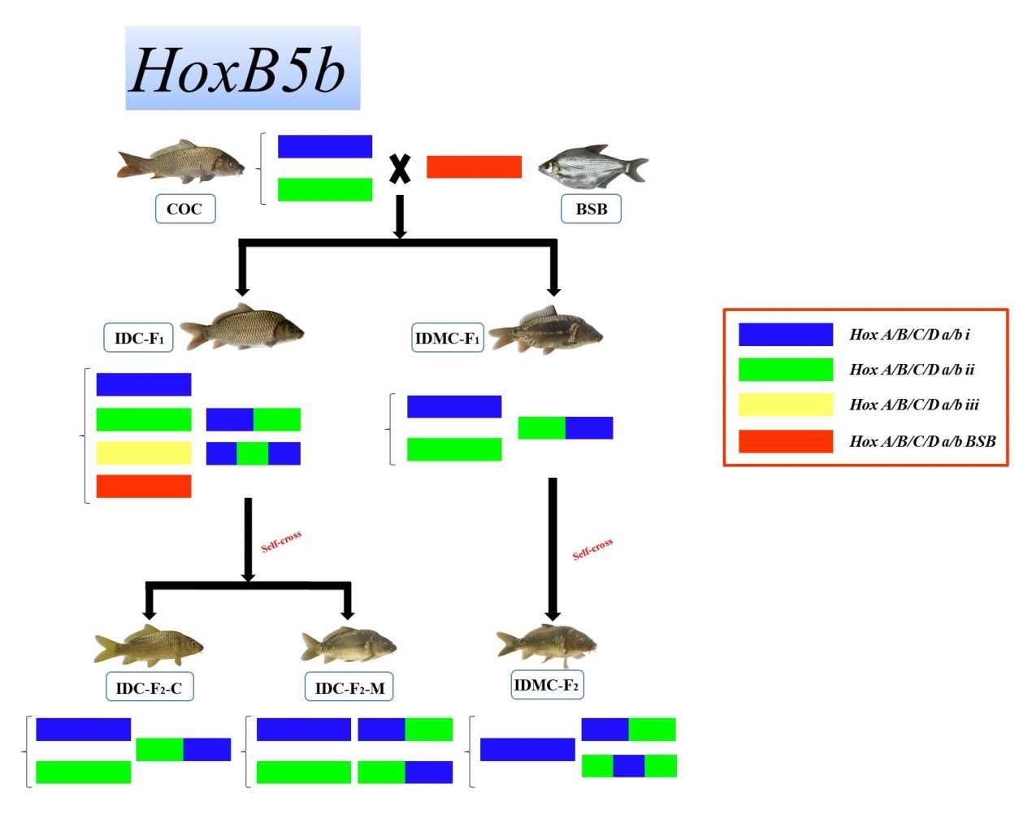

Supplementary Figure S3. Variable sequence types (including haplotypes and recombinant clusters) in HoxB5b in these species.

Supplementary Information Tables
Supplementary Table S1. The 12 combinations of degenerate PCR primers designed based on the alignment and identification of consensus sequences of orthologous Hox genes from zebrafish (Danio rerio), medaka (Oryzias latipes), rainbow trout (Oncorhynchus mykiss), pufferfish (Fugu rubripes), mouse (Mus musculus), and humans (Homo sapiens).

No | Gene | Forward primer | Reverse primer
1 | HoxA4a | TACATTTGACAGAGGAGTAGGT | TGTGSTCYTTCTTCCACTTCA
2 | HoxA9a | TCGGCCCCTGCACATTC | CATCCTGCGGTTTTGGAACCANAT
3 | HoxA2b | CTCGCTGAGTGCCTGACAT | GAGAAAACRTTGAAGTCCTGYAAA
4 | HoxA11b | GGATGATGGATTTTGATGAGC | TTTTCYTTGTTGATGTARACACTGA
5 | HoxB1a | GCCACCAACAGCAGCAGCAC | CTTGGAGAGGCTTCTGGAGATG
6 | HoxB4a | CCTAAGTTTCCACCCTGCGAG | GCGGATTTTGGTGTTGGGAAG
7 | HoxB1b | ATAGTTACATTCCCGAGG | ACCTGCGTTTCGTTCAGTTC
8 | HoxB5b | ACTCSTTCTCRGGGCGYTA | TTTCAGTTTATTGTCCTTCTTCCA
9 | HoxC4a | GGACTCTAACTACATCGATC | GAGGACGAGGATCTGACTTTG
10 | HoxC6b | GATGAATTCCTAYTTYACKAACC | AYTTCATCCGGCGGTTCT
11 | HoxD4a | AGAGCCCAGGCTACTACA | CTTTCGTGTTTGGTAGTTTGTG
12 | HoxD10a | GGA ATGCAAACCTGTGGACT | TCKGCTCATCTTCTTGAGTTTCA

R = A/G; Y = C/T; S = G/C; W = A/T; K = G/T; M = A/C; B = C/G/T; D = A/G/T; H = A/C/T and V = A/C/G.

